**Programming for Computer Games – Home Assignment 1**

Question 1A

To conduct this assignment, I will be making use of *Unity Game Engine* instead of the game engine that was taught last year known as *Construct (2).*

Reasons why I chose Unity instead of Construct 2 :

* Firstly, Unity makes prototyping a project much faster and easier than Construct 2 due to the fact that Unity provides a considerable amount of in-built features, such as animation and an easy to use drag and drop interface.
* In addition, Unity gives you the freedom to use any scripting language you prefer. Construct 2, which does not make use of any scripting languages relies only on the inbuilt functions of the editor, thus making Construct very limited on game designing and functions.
* Another point is that the learning curve on Unity is much better than Construct 2 because Unity offers itself a variety of video and text-based tutorials. Moreover, Unity has better structure when adding scripts to objects (by just attaching it to the object).
* Finally, Unity gives you the ability to transfer your project to over 20 different platforms such as virtual Reality, mobile applications and console. Construct 2 is most of the time computer based, making the transfer from Construct to other platforms difficult and may not run well.

Question 1B

Two of the most common programming languages that are used in game development include JavaScript and C#. In this assignment, I will be using C#, when comparing the two languages both of them have their own advantages and disadvantages but I chose C# for the fact that it has a lot of useful features, such as:

* Management: C# is an object oriented programming language, this makes editing the code, and managing it much easier than a procedure oriented language.
* Type Safe : C# is a type safe language, meaning that it cannot access memory location that it does not have permission to. Thus, improving the security of the program.
* Inheritance : Since C# is based on .NET, it inherits features such as garbage collection and auto memory management.
* Library : C# has a rich library of various functions which makes programming much faster and easier.

Question 2A

Play Again is clicked

End Scene

Game – Level 3

Start Scene

Game – Level 1

Game – Level 2

[playerscore =32]

Play is clicked

[playerscore =16]

[playerscore = 6]

Question 2B

Player 1 has ball

Middle Mouse Button Clicked

hit

Ball is in air

Ball reset to original position

hit

hit

hit

Bounce back

Bounce back

Bounce back

Ball – Goalpost Collider

Ball – Player

Ball - Normal Collider

Ball - Obstacle

Question 3

[playerScore = 16] Max score is reached

Level 3

Why is compression needed when using images, audio and videos?

Data compression is needed for the reduction of size from the files that are being used. In reference to game development, this makes the game a much less smaller size as well as reduces the loading time and reaction time of the computer.

An example of compression is known as *“Lossy”* compression . This compression style is mostly used on file types such as images, videos and audio. This compression reduces some of the quality in order to save data space, but most of the time the quality loss is almost never detectable. (Lostsaloon.com, 2017)[1]

Another example is known as *“Lossless”* compression. This type of compression creates the file from start to finish slowly without losing any quality during or after the compression and is a must if for compressing files that include text. (Lostsaloon.com, 2017)[1]

Lossless Compression

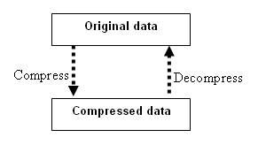

This compression type can be applied to the majority of computer data such as images, text and even software applications. A common format used to do this is the *.zip* format. Hence the name lossless, it does not reduce the data’s quality, but on the downside does not reduce the file size as efficiently as lossy compression.

Lossy Compression

However, this compression type finds redundancy of pixels and completely removes it. This type of compression is not valid for text and software since they are required to have all the data, but on media items such as images etc. In short there is so much detail in media graphics that the human eye will not notice if some data is gone.

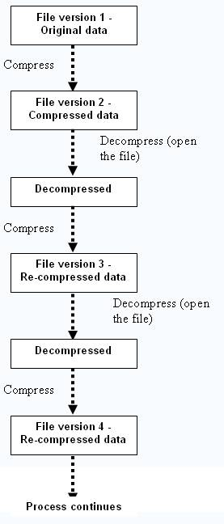

**Github Link : https://github.com/Gowxtar100/AssignmentV2.git**

**Reference List**

1. Lostsaloon.com. (2017). *What is data compression and why use it – lost saloon*. [online] Available at: http://www.lostsaloon.com/technology/what-is-data-compression-and-why-use-it/

[Accessed 26 Nov. 2017].